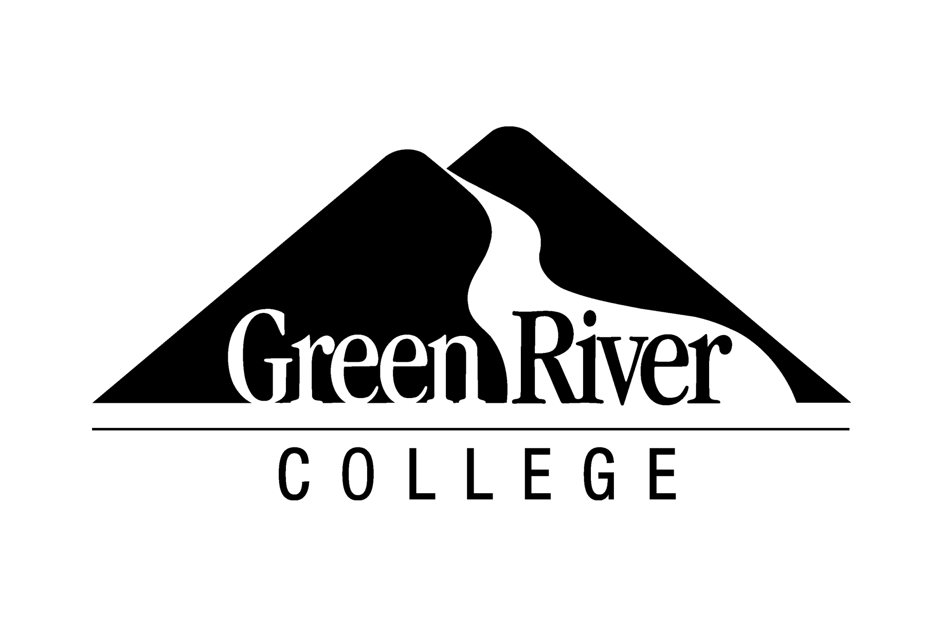

GreenRiver.edu/RunningStart • (253) 288-3380 • 12401 SE 320th St., Auburn, WA 98092
Intent to Graduate Through College-Issued High School Diploma Form
Running Start students may earn a high school diploma issued by Green River College by completing any associate degree, even if they have not otherwise met the high school graduation requirements (e.g., credits, state assessments, high school and beyond plan, and culminating project)*. While this option may be beneficial for some students, there are several important considerations to make before deciding to pursue this option.

Instructions:
- Meet with your GRC Running Start advisor to create an educational plan (Ed Plan) and review the considerations;
- Meet with your high school counselor to review this form and your Ed Plan, obtain the signatures below;
- Submit this form and a copy of your Ed Plan to the Running Start Office in SA 135 or RunningStart@GreenRiver.edu;
- Complete the online Intent to Graduate Form in January of your graduation year, indicating you are completing TWO programs at GRC: your AA and your HS Diploma. https://www.greenriver.edu/students/academics/enrollment-services/graduation/intent-to-graduate/
- Bring an official copy of your final GRC transcript to your high school for local, state and federal reporting. Students who do not may be reported as non-grads, or having dropped out of school.

Considerations:
- Completing an associate degree requires careful course planning.
  - Students must develop an educational plan with a Running Start advisor to ensure accurate course planning and feasibility of earning an associate degree within the timeframe of Running Start participation.
  - Full-time enrollment at the college is necessary to earn an associate degree within two years.
  - A student should have alternate plans in case they do not complete all credits required for their degree.
- To be eligible for financial aid, a student must have a high school diploma or GED. If a student exhausts their eligibility in Running Start (only junior and senior year), they must pay full tuition for remaining credits to earn their associate degree/high school diploma and then will be eligible to receive financial aid.
- Participation in activities at the high school may be limited. This includes participation in graduation ceremonies and may include extracurricular activities. Students should consult with their high school regarding local policies.
- University admission requirements.
  - Completion of an associate degree does not guarantee admission to a university.
  - Students must complete application processes, such as meeting College Academic Distribution Requirements (CADRs: https://wsac.wa.gov/sites/default/files/2014.CADRS.Detailed.pdf) or taking a test such as, SAT or ACT. Please consult with the admissions office at any universities you plan to apply for specific requirements.

I, ___________________________________ (print full name), have developed an educational plan with my Running Start

advisor, _______________________________________. I understand my responsibilities, risks and wish to earn my high school diploma through Green River College.

Student Signature _____________________________________ Date____________________ Student ID # __________________________

Parent/Guardian Signature ____________________________________________________________________ Date____________________

High School Counselor Signature _______________________________________________________________ Date____________________
*In 2009, Washington State Legislature passed Substitute House Bill 1758 (RCW 28B.50.535) allowing students earning an associate degree from a community or technical college to receive a high school diploma issued by the college. http://apps.leg.wa.gov/rcw/default.aspx?cite=28B.50.535.
Green River College does not discriminate on the basis of race, creed, color, national origin, sex, sexual orientation, age, marital status, religion, disability, genetic information or on any other unlawful basis. The college is committed to preventing and stopping discrimination, including harassment of any kind and any associated retaliatory behavior. The following person has been designated to handle inquiries regarding the non-discrimination policies: Vice President of Human Resources, 12401 SE 320th Street, Auburn, WA 98092, (253) 288-3320 Disability Support Services at (253) 833-9111, ext. 2631; TTY (253) 288-3359.

