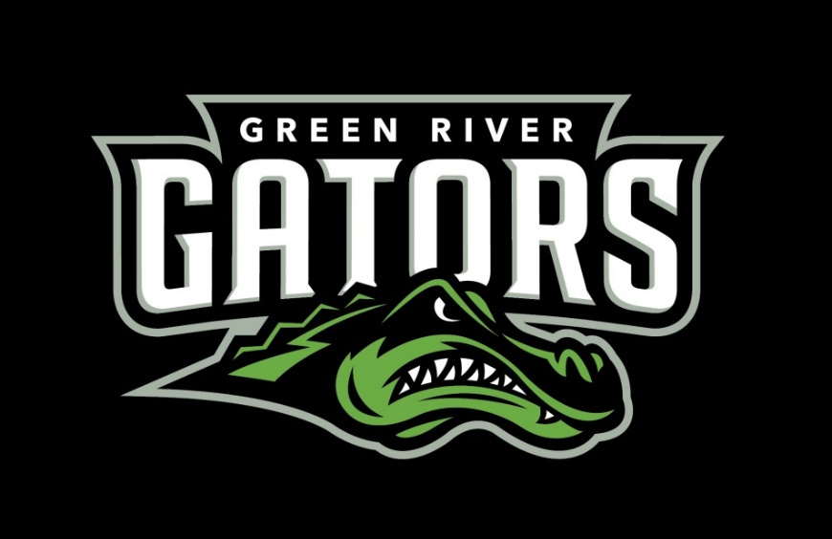
2025-26 Green River Track & Field Schedule
Date Host/Schools Participating Location
March 7 UPS Ed Boitano Invite Tacoma, WA
(10k/Hammer Friday March 6th)
March 13/14 PLU Invite Tacoma, WA
March 21 PLU Brad Moore Invite Tacoma, WA
March 28 UPS Peyton Shotwell Invite Tacoma, WA
April 3 Whitworth Peace Meet Spokane, WA
April 17/18 Lewis & Clark Larry Byerly Invite Portland, OR.
April 25 WWU Ralph Vernacchia Invite Bellingham, WA

May 18-19 NWAC Championships Gresham, OR
(Mt. Hood Community College)
Head Coach: Kevin Jackson
Assistant Coaches: Adam Leahy and Jordan Jackson

Updated: 4/01/26

